[1]

Initial Design Proposal

Group 4 Alejandro Garcia, David Ozoude, and Lora Milam

# INTRODUCTION

T

he goal of this project is to build a robot capable of seeking out and firing at targets at varying ranges. To accomplish this, the robot will move along a reflective tape which will be used to chart a course for the robot to follow. At specific intervals which will be indicated by red tape, the robot will stop and seek out a target which will be placed at a random position a few feet away. Upon locating the target, the robot will fire at it in a bid to deactivate it. Once this has been accomplished, the robot will then move on to the next patch of red tape and the process will be repeated two more times. Once this has been accomplished, the robot will trudge ahead till it detects a green patch of tape which when detected, will trigger the robot to head back in the direction it came from but this time without stopping at the red patches. The autonomous search-and-destroy robot will be both hardware and software intensive. Details of how all this will be accomplished will be discussed in the coming paragraphs.

There are three main circuit blocks which consist of: the light filtering and detection circuit, the H-Bridge motor control circuit, and the tape detection circuit. The first circuit block to kick into action will be the tape detection circuit. This will comprise mainly of two color detection sensors, one of which will be programmed to detect green light, and the other to detect red light, and another sensor to detect the reflective tape and keep the rover on course. When the tape detection circuit registers the green tape, it’ll trigger the H-Bridge motor control circuit into action. This is concerned with the locomotion of the rover and the robot at large. When green tape has been detected by the Tape detection circuit, the H-Bridge motor control circuit will kick into action and propel the rover forward. It’ll remain in motion until the tape detection circuit reads red tape. This will cause the H-Bridge motor circuit to cease operations. When this occurs, the final circuit block, the light filtering and detection circuit, will commence operations. The function of this block is to seek out the target, and cause the firing mechanism to ‘destroy’ it once found. The location of the target will be attained by an integration of a phototransistor which will detect the light and convert it into voltage. It will work hand-in-hand with a band-pass filter which will be used to sieve out light of unwanted frequencies, permitting only light with a frequency of 20Hz to pass through and be converted. This will be accomplished by a series of capacitors and resistors which will filter out the ‘noise’ or unwanted voltages and only allow the desired one pass through. One the target has been located, a pulse will be sent to the Basys 3 board, and then to the firing mechanism which will then proceed to shoot at the target three times. After this has been accomplished, the H-Bridge motor control circuit will fire up and move on to the next red patch which will be detected by the tape detection circuit and the process is repeated two more times till the tape detection circuit scans a green patch and causes the robot to head back to the beginning of the course but this time, without stopping at any of the red patches.

The integration of the hardware and software in this project will be integral to peak functionality if any at all. As stated in the heading, this is going to be an ‘Autonomous Search and Destroy Robot’ with an emphasis on ‘Autonomous’ and ‘Search’ meaning that this will have to be able to ‘think’. But for all the coding to function properly, it needs a channel. One that will be provided by the hardware. The task is clear, as are the instructions. These will be followed to the best of our ability and come demo day, we’ll turn in a fully functional robot.

# Hardware Blocks

For this project we have multiple hardware components that we are going to utilize to complete and implement this project. To start we have the Basys 3 board which is the brains of the operations. Pretty much every additional circuit component and or hardware block is going to interact with the Basys 3 in some way. This is the tool that we are going to utilize to connect the hardware and software components together. The next components are the sensor components, one to detect the target and another one to follow the track by detecting the reflective tape, red tape and green tape. Each of these sensor components will have their respective additional circuit blocks. Next we have the power supply component which we have chosen the Tenergy 9.6v 2000mAh rechargeable battery due to its rechargeable nature and suitability for powering the rover. A crucial component of this project is the firing mechanism. Our initial idea is similar to an airsoft gun when it comes to the barrel but we want to try and use a gravity loaded magazine that way the plastic bbs just drop in after each shot. The primary issue that we have to flesh out with this mechanism if how we are actually going to fire it; we can do it either mechanically or electrically. As a group we need to decide which would be more ideal and realistic to implement. The main base of this project is the Rover5 chassis. This is where everything is going to go on when it is complete and also be the primary moving component since the rover is going to run the course. Lastly we have the servo motor components. There are primarily going to be used to move the firing mechanism.

# Software flowchart

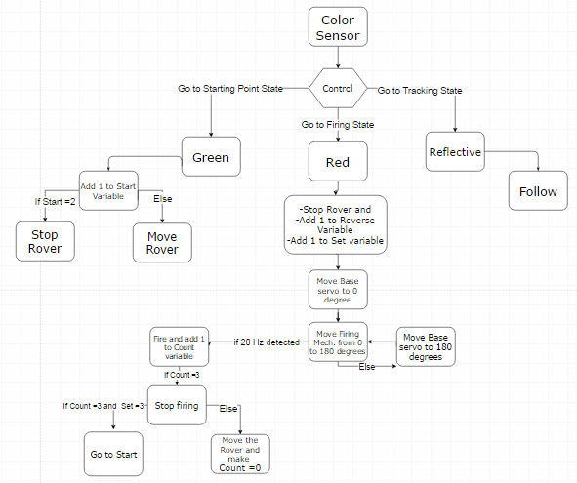

Provided by draw.io

The image provided above illustrates the general process of our software.

# project timeline

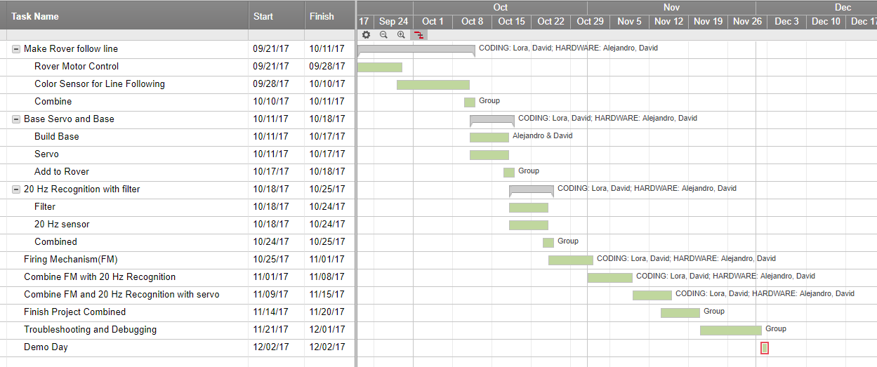

Provided by Smartsheet.com

Indicated by the image provided above, we have dictated dates we plan to complete certain aspects of the project. Also indicated by the image provided, tasks have been divided among all of the group members. Alejandro Garcia will have the task of leading the development and design of the hardware components. Lora Milam will have the task of leading the creation and application of the coding. David Ozoude will fluctuate between both the coding and hardware aspects of the project and assist in the section that is in the most need of assistance.

# Budget

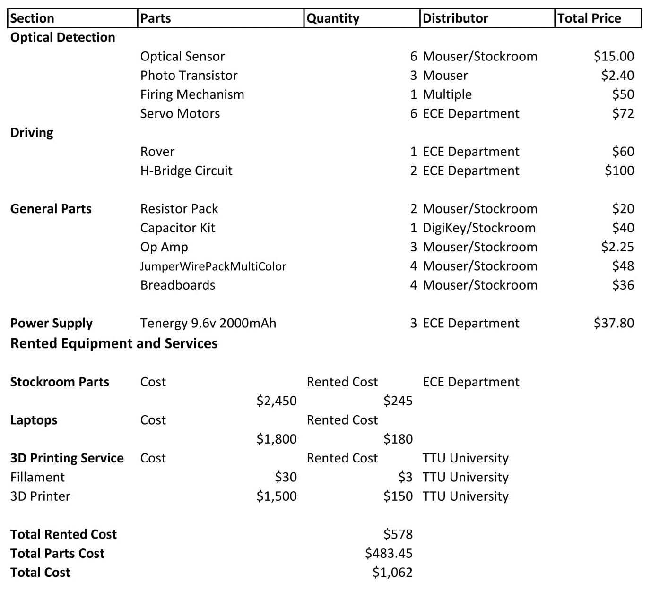

For the budget we decided to go focus on some of the general parts that we are going to need for our different circuit blocks since we haven’t fully designed our circuit blocks yet. That is why we decided to get some resistor packs and capacitor kits that way we can have a good variety of each to work with. The same goes with the jumper wire kits and the breadboards. For the optical sensors, op amps, phototransistors and the servo motors we also gave a general estimate because we were not sure about the specifics just yet. For a lot of these parts they might be readily available in the stockroom so when that is the case we will be sure to update the budget in the future differentiating whether it was a part from the stockroom or a part we ordered. Any extra parts that we get either ordered or from the stockroom will be added as extra to the budget when it happens as well as other expenses. This includes parts that are not listed or parts that we needed even more of. For the firing mechanism we picked fifty dollars as a good point that way it gives us a little room to experiment with a mechanical firing mechanism or an electrical one. It also lets us test different reloading ideas if our gravity loaded magazine does not work and also the barrel of the firing mechanism and additional details that need to still be ironed out. Once the design is fully finalized that will be included in the budget including if we had to go over our initial estimate and by how much. The rover chassis and the H-Bridge circuits were provided to our group by the ECE department. For the power supply we decided to go with three Tenergy 9.6v 2000mAh rechargeable battery packs. One should be sufficient but we have two extras just in case. For our lab bench I got a rough estimate of two thousand four hundred and fifty dollars for the cost of the equipment. Since we are going with a ten percent rate for the rental we ended up with two hundred and forty five dollars for the lab bench. We did the same for our laptops and the total rented cost is about one hundred eighty dollars for the laptop. The 3D printing is going to be used for the base of our firing mechanism and to cover our rover up making sure that there is not too much exposed. For the cost of this we got the average cost of the filament and 3D printer and applied the ten percent formula. With this we have our total estimate for our budget that we are going to try to adhere to.

# Conclusion

# references

A. (2015, October 25). How Much Does a 3D Printer Cost? Still Expensive, But Becoming More Affordable.

Free flowchart maker and diagrams online. (n.d.). Retrieved September 21, 2017, from <https://www.draw.io/>

Mouser Electronics – Electronic Components Distributor. (n.d.). Retrieved September 21, 2017, from

http://www.mouser.com/

Retrieved September 21, 2017, from https://mic.com/articles/41111/how-much-does-a-3d-printer-cost-still

expensive-but-becoming-more-affordable.

SmartSheet. (n.d.). Retrieved September 21, 2017, from <https://app.smartsheet.com/b/home>

World’s Largest Selection of Electronic Components Available for Immediate Shipment!. (n.d.) Retreived

September 21, 2017, from https://www.digikey.com/

1. This work was submitted 21 September 2017. This work was supported in part by the Electrical and Computer Engineering Department at Texas Tech University.

   David Ozoude is currently a junior pursuing a major in Electrical Engineering at Texas Tech University.(e-mail: david.ozoude@ttu.edu).

   Alejandro Garcia is currently a junior pursuing a major in Electrical Engineering at Texas Tech University.(e-mail: alejandro.g.flores@ttu.edu).

   Lora Milam is currently a junior pursuing a major in Computer Engineering at Texas Tech University.(e-mail: Lora.k.milam@ttu.edu).